**Patron/ Chairmen**

……………………………….

**Convener**

……………………………….

…………………………….....

**Coordinators**

……………………………..

………………………………

……………………………………

**Organizing Committee Members**

…………………………………..

…………………………………….

…………………………………….

…………………………………….

**Address for Correspondence**

Coordinators Name………………

*Designation……………………….*

*Department ………………………*

Email: …………………………….

Contact No……………………….

Coordinators Name………………

*Designation……………………….*

*Department ………………………*

Email: …………………………….

Contact No……………………….

**Self Finance**

**Short Term Training Program (STTP) on “……………………………………..”**

**From……..to……..**

**REGISTRATION FORM**

Name: ………………………………………

Designation: …………………..……………

Organization: ………………………………

Qualification: ……………………………….

Correspondence Address: ………….……

……………………………………..............

..................................................................

Tel. (O) ………………. (R) …..……….......

(M) …………………………….……........

E-Mail: ………………………..…………….

Registration Fee is paid in the form of Cash/DD

Amount ………………...........................

No...............................Date ……………

Name of the Bank……………………..……

Accommodation Required: Yes / No

Date: Place:

Signature

Note:

◾ Demand draft should be made in favour of Director, National Institute of Technology Raipur, payable at Raipur.

◾ Photocopies of registration form may be used.

**One Week Self Financed**

**Short Term Training Program**

**on**

**----------------------------------**

**From………to…………….**

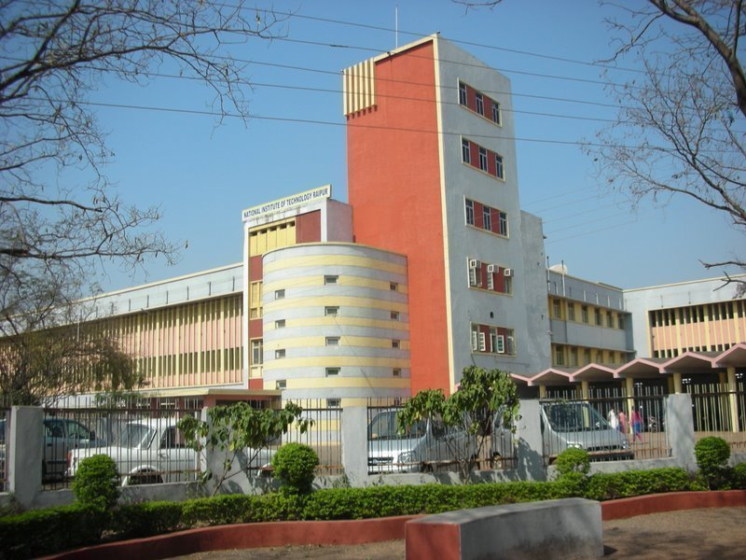

***Organized by***

**Department Name**

**National Institute of Technology**

**Raipur-492 010 (Chhattisgarh)**



**About the Institute:**

**National Institute of Technology Raipur** situated in the capital of Chhattisgarh, has proven to be "avant-grade' in the field of science and technology over past few decades in this region. With sweet memory of foundation ceremony by our president Hon'ble Dr. Rajendra Prasad on 14th September 1956. the institute started with two departments namely Metallurgical and Mining Engineering. Later the inauguration of the Institute building was done by our Prime Minister Hon'ble Pt. Jawahar Lal Nehru on 14th March 1963. From 1st December 2005, the institute has become the National Institute of Technology. It is well connected with Mumbai, Delhi and all metro cities by regular flights and is on the main Howrah-Mumbai railway route. The institute is 5 km from the Raipur railways station and 18 km from airport on NH-6, the Great Eastern Road.

**About Department:**

…………………………………………………………………………………………………………

**Venue:**

**Department ………………….**

**NIT Raipur (CG) – 492 010, INDIA**

**Topics to be covered:**

**………………………………………**

**Targeted Participants*:***

* …………………….
* …………………….
* ……………………...

**Registration Fee Details (in INR):**

|  |  |
| --- | --- |
| **Participants** | **Amount (in Rs)** |
| Students |  |
| Faculty |  |
| Industry Delegates |  |

Application in the prescribed format with registration fee in the form of Demand Draft drawn in favor of “**Director, NIT Raipur**” must reach the coordinator on or before ……, 20…. Registration fee includes registration kit, tea and lunch during the program. Fee is non-refundable**.** Selected candidate will be informed by email as per the schedule. Certificates will be issued to the participants only after attending the complete course.

**Objectives:**

………………………………....

**Theme/Scope:**

……………………………………..